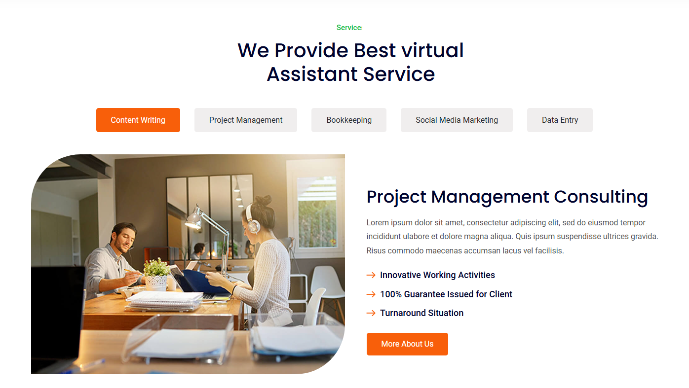

**1st DIV ------from the below link. Only this part will taken.**

[Vconn - Virtual Assistant Services HTML Template (hibootstrap.com)](https://templates.hibootstrap.com/vconn/default/service-2.html)

Service details page Link

[Vconn - Virtual Assistant Services HTML Template (hibootstrap.com)](https://templates.hibootstrap.com/vconn/default/service-details.html)

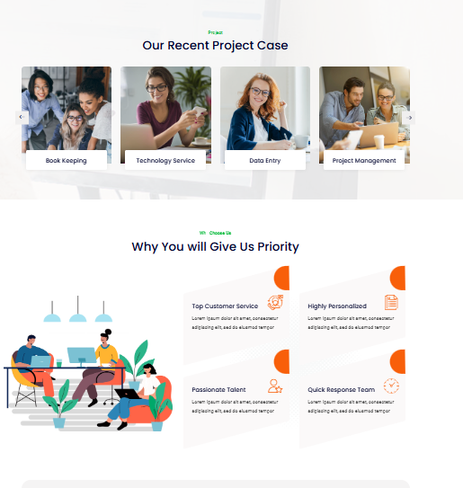

**2nD DIV ---2nd and 3rd part will be taken**

[Vconn - Virtual Assistant Services HTML Template (hibootstrap.com)](https://templates.hibootstrap.com/vconn/default/service-1.html)

Others will be removed